**How to log into Microsoft Teams**

For computers, iPads, tablets, cell phone:

* Using your browser (Google, Firefox, etc.), search for Microsoft Teams
* Click the Microsoft Teams link (<https://www.microsoft.com/en-us/microsoft-365/microsoft-teams/group-chat-software>)

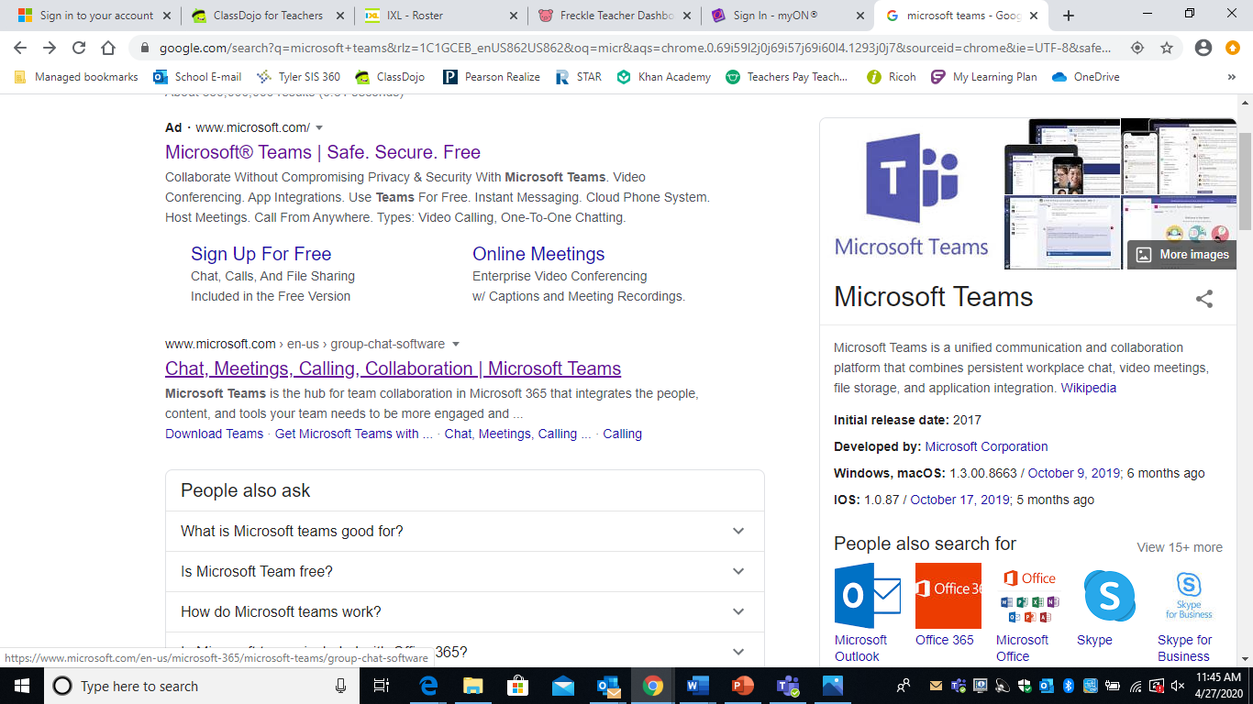

* Click the purple Sign in box

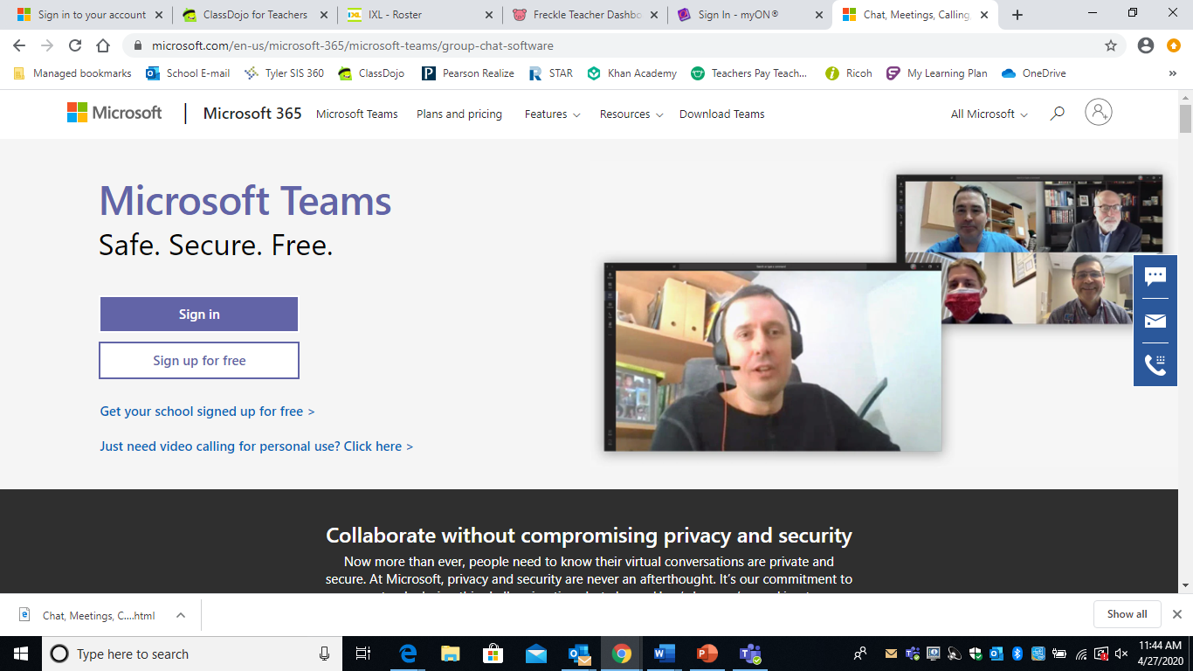

* Using your child’s information, you may log in.
  + Username: [AccountID@slps.org](mailto:AccountID@slps.org)
  + Password: (password)

For the iPad, a tablet, or cell phone (that has downloading capabilities):

* Go to the app store search for ‘Microsoft Teams’





* Download the app ‘Microsoft Teams’
* Log in using your child’s given information
  + Username: [AccountID@slps.org](mailto:AccountID@slps.org)
  + Password: (password)